
Vidyavardhini’s College of Engineering & Technology
Department of Computer Science & Engineering (Data Science)

NAME: Samar Santosh Sawant
Div : SE3-B2
Roll No: 35 Branch: CSE-DS Experiment No: 1
DOP (Date of Performance) : 05/01/26
DOC (Date of Completion) :
12/01/26
Experiment Title: Installation of XAMPP & Git, Creation of Git Repository, and Execution of Basic Git Commands
AIM: To install XAMPP and Git, create a GitHub account, set up a new Git repository, and execute fundamental Git commands such as add, commit, modify, view, and branch management for understanding version control.
Instructions:
- Install XAMPP
- Install Git. Create an account on GitHub.
- Go through the Git GitHub PDF file and execute 4/5 git commands.
- Take snapshot of git commands and your github account page. Save these in one docx file. Create pdf and upload it as submission part.
Git commands executed in Git Bash :
  - Checking the Installed Git Version Using git –version
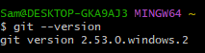
  - Initializing a New Git Repository Using the git init Command
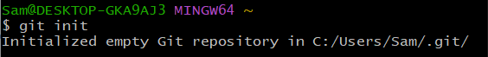

  - Checking the Current Repository Status Using git status

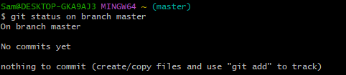

  - Configuring Global Username and Email Using Git Config Commands

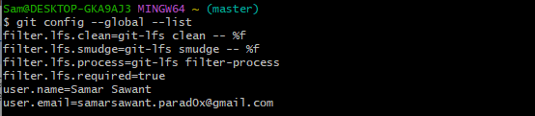

Creating a File Using the Echo Command
Adding a File to the Staging Area Using git add and Resolving the Warning Using core.autocrlf Configuration
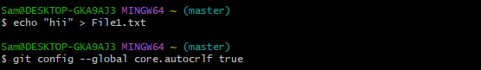

Verifying the File Status Using git status

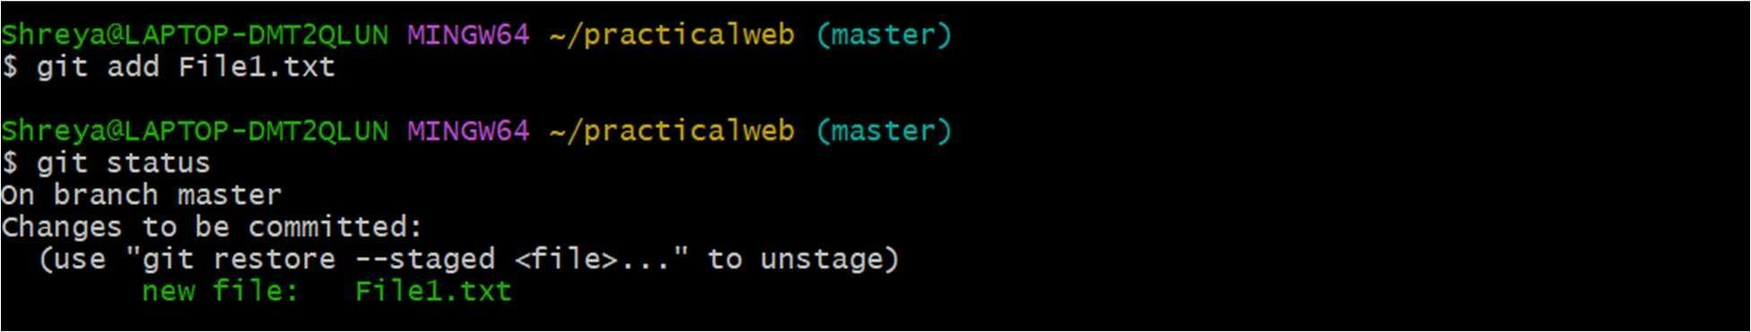

  - Executing the First Commit Using git commit
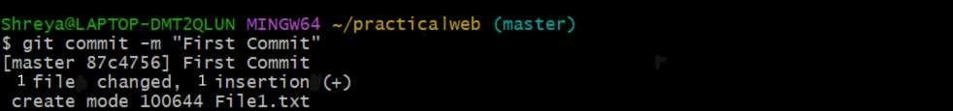
Your GitHub account home page :

